Indian Institute of Information Technology, Sricity



OOPS PROJECT REPORT

**चूक ना जाना**

“Delishably”

**का खाना**

Restaurant Chain Management with data Visualization System

**TEAM-15**

**Submitted By:**

* Akansh Vaibhav - S20210010010
* Anmol Kumar Pandey - S20210010022
* Akash Singh Narvariya - S20210010012
* Dhruv Raj - S20210010066
* Rohan Kumar - S20210010194

| **TABLE OF CONTENTS** |
| --- |

| **S. No.** | **Description** | **PAGE No.** |
| --- | --- | --- |
| **1** | **Abstract** | **2** |
| **2** | **Methodology** | **2** |
| **3** | **UML Diagram** | **3** |
| **4** | **ER Diagram** | **3** |
| **5** | **Working** | **4** |
| **6** | **Contributions** | **5** |
| **7** | **Result** | **6** |
| **8** | **Conclusion** | **7** |
| **9** | **Technologies Required** | **7** |

**ABSTRACT:**

The aim of the Restaurant Chain Management System is to create an admin application that can be used by the Restaurant Owner and Workers which helps to improve their efficiency and to maximize the profit margin of restaurant owners by providing them better service which includes data visualization as well. The system caters to three types of users within an organization namely:

* Restaurant Chain Owner
* Branch Manager
* Regular Employee

Each of them has different access permissions and different features to work with.

This project is GUI based and uses MySQL as its Database System to manage all the humongous data. It uses JDBC Library to connect the Database and Java code. The GUI and data visualization in the project is made by JavaFX.

**METHODOLOGY:**

The whole project has been done in three Phases.

* Phase 1 consisted of planning the project. In this phase, we decided on the possible tables and classes for the project and divided the work among every member
* In Phase 2 each member did their respective work separately and completed their part.
* In Phase 3 we integrated all the work done by individual members to bring the project to completion. Thus, making it run properly and successfully.

**UML DIAGRAM:**

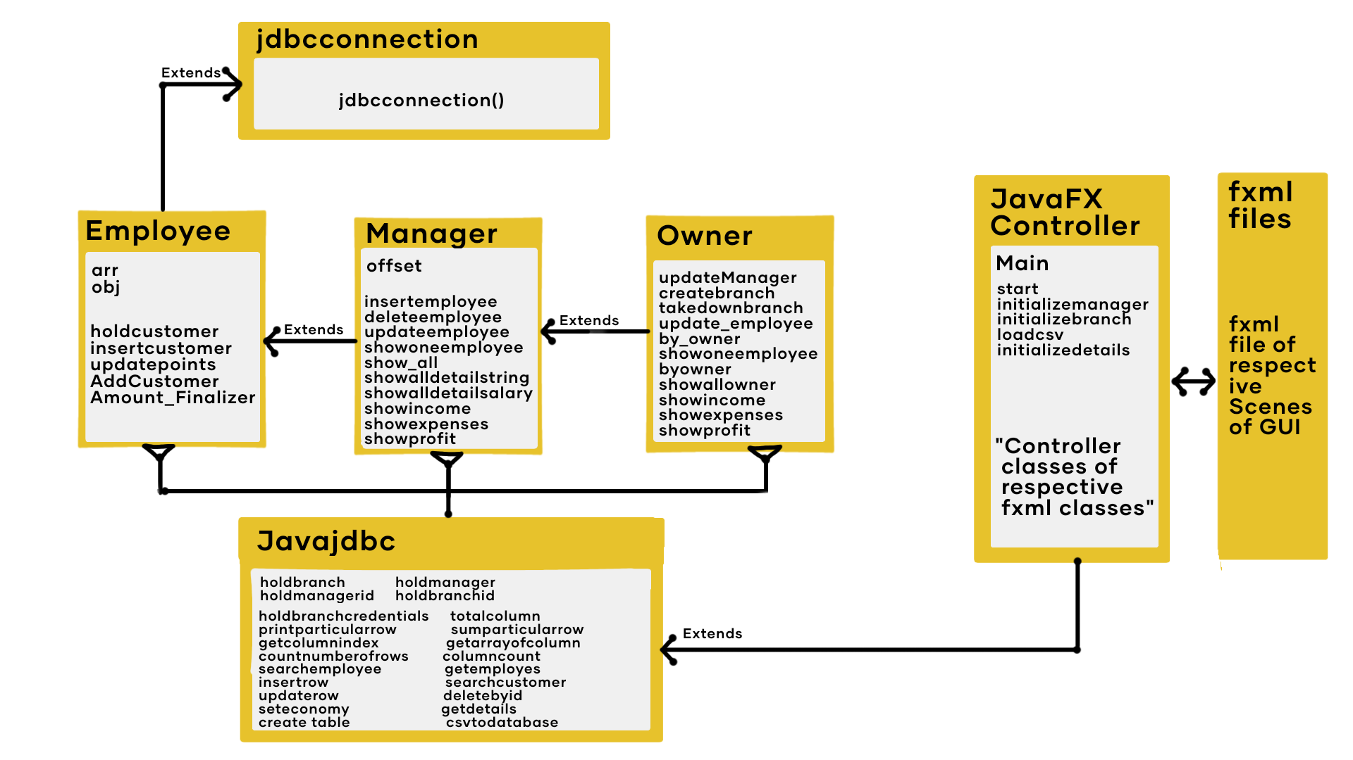

**ER DIAGRAM:**

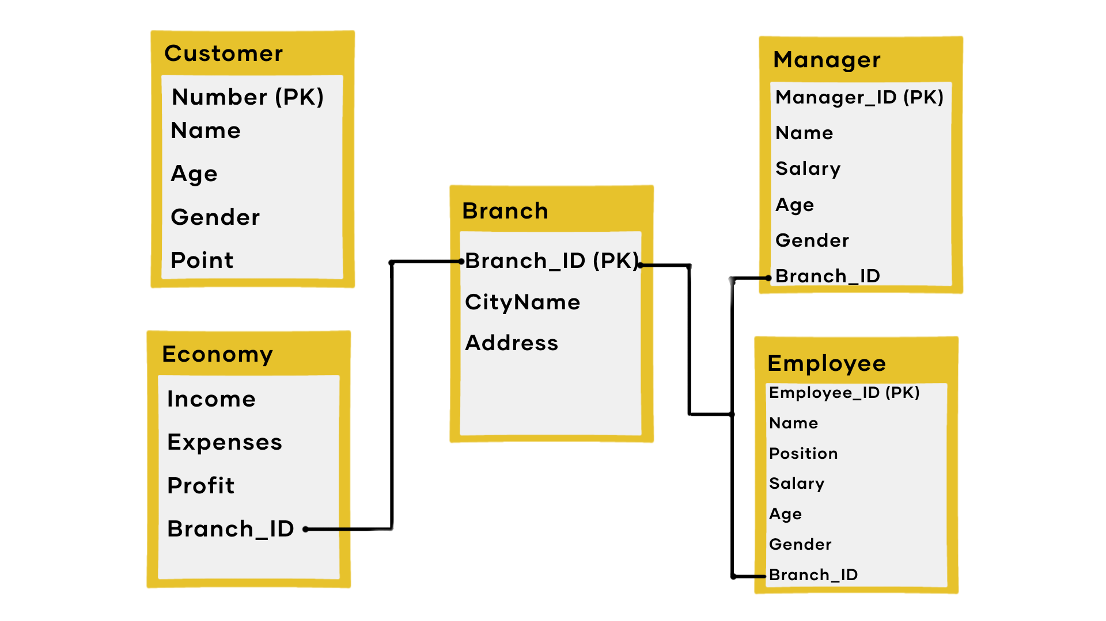

**WORKING:**

The application gives the following services to all the users:

**Employee:**

The Application allows the “Employee” to take orders from the customer. It shows the menu and lets them select items for the final bill. Other than this, it also adds the customer to the Restaurant database to give discounts based on a previous order and if a new customer is there, it adds it to the database.

**Manager:**

The Application allows the “Manager” to manage Employee and Economy, including adding, deleting, updating and viewing Employee details. It also has functions to see the income, expense and profit of the respective store. In the view Employee function, the Manager can view based on unique ID, name, and salary or see every Employee's details at once.

**Owner:**

The Application gives the “Owner” Manage Branch, Manage Manager, Manage Store and Data Visualization Options. With the Manage Branch option, the Owner can create a new Branch and assign a new Manager to it or take down an Existing Branch and all data related to it. With the Manage Manager option Owner can update the details of an existing Manager and with the Manage Economy option, the Owner can view the income, expenses and profit of the whole Restaurant Chain.

**CONTRIBUTIONS:**

Contributions of Each Member is as follows:

Akansh Vaibhav - S20210010010

Created the holdcustomerdetails, insertcustomers, updatepoints, AmountFinalizer methods in Employee class along with providing MySQl Queries and worked on Scene Builder for GUI.

Anmol Kumar Pandey - S20210010022

Created the loadCSV , updateManager, CreatenewBranch, takedownBranch, overridden methods in Owner Class and Controller Class of JavaFX along with CSS Stylesheet for GUI.

Akash Singh Narvariya - S20210010012

Created the showoneemployee, show all, showbypartioalstring, showbysalary, initializedetails, intiliazemanager and intializebranch methods along with Controller Class of JavaFX and CSS Stylesheet for GUI.

Dhruv Raj - S20210010066

Created the Javajdbc Class and all methods in it along with Connecting Controller classes with other class methods. Contributed in CSS Stylesheet and made jdbc abstract class along with establishing connection in MySQL.

Rohan Kumar - S20210010194

Created insertEmployee, updateEmployee, deleteEmployee, showIncome, showExpenses and showProfit methods in Manager and Owner Class. Created CSVs and helped in Scene Builder for GUI.

**Sign of All Members:**

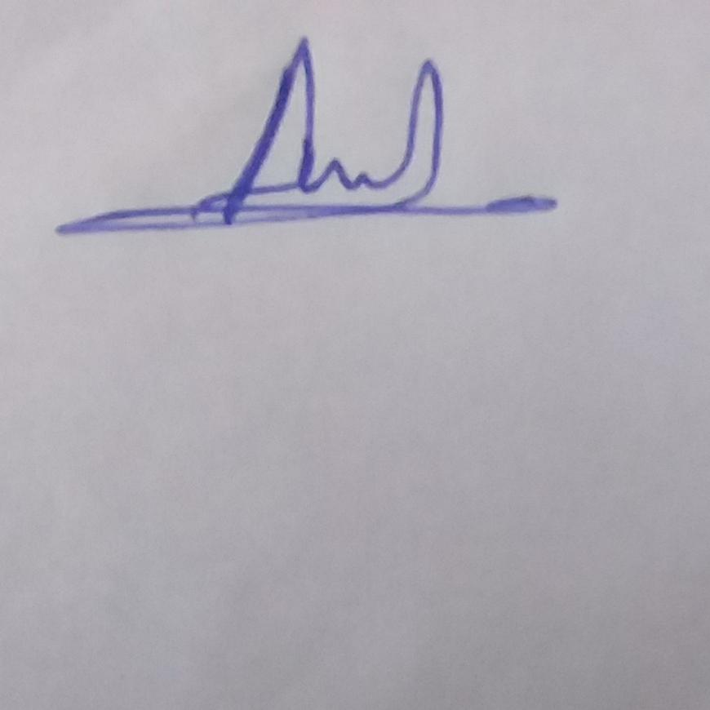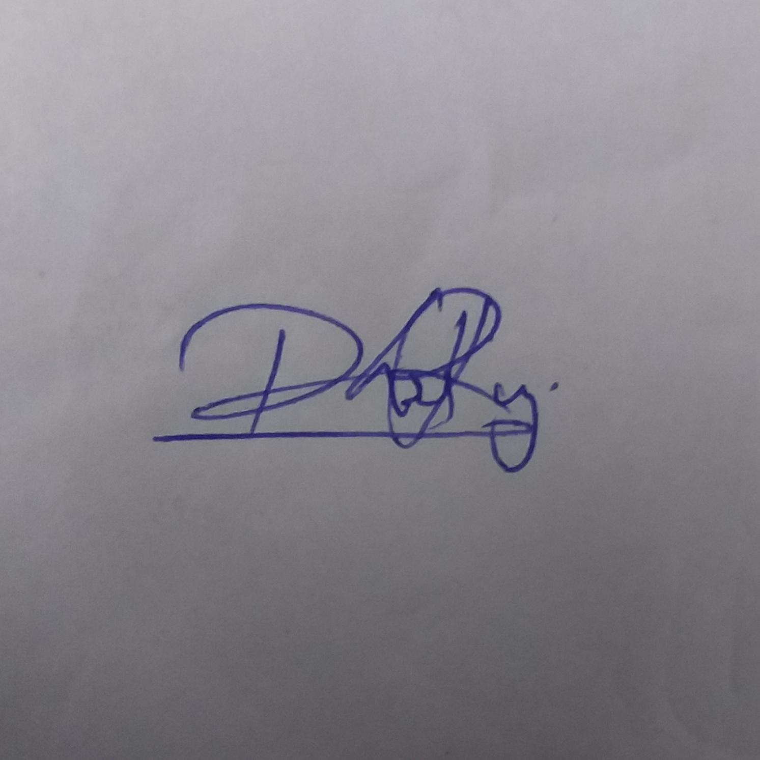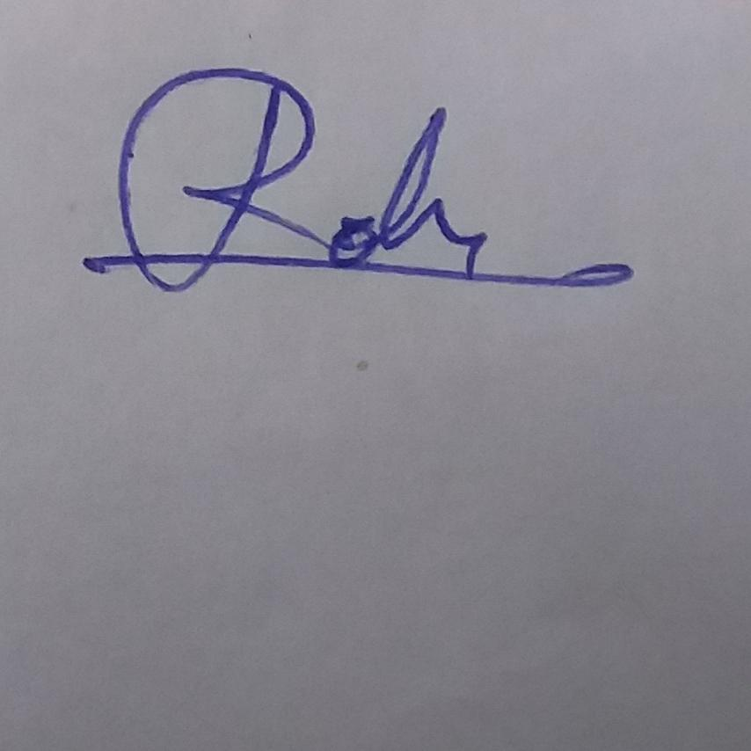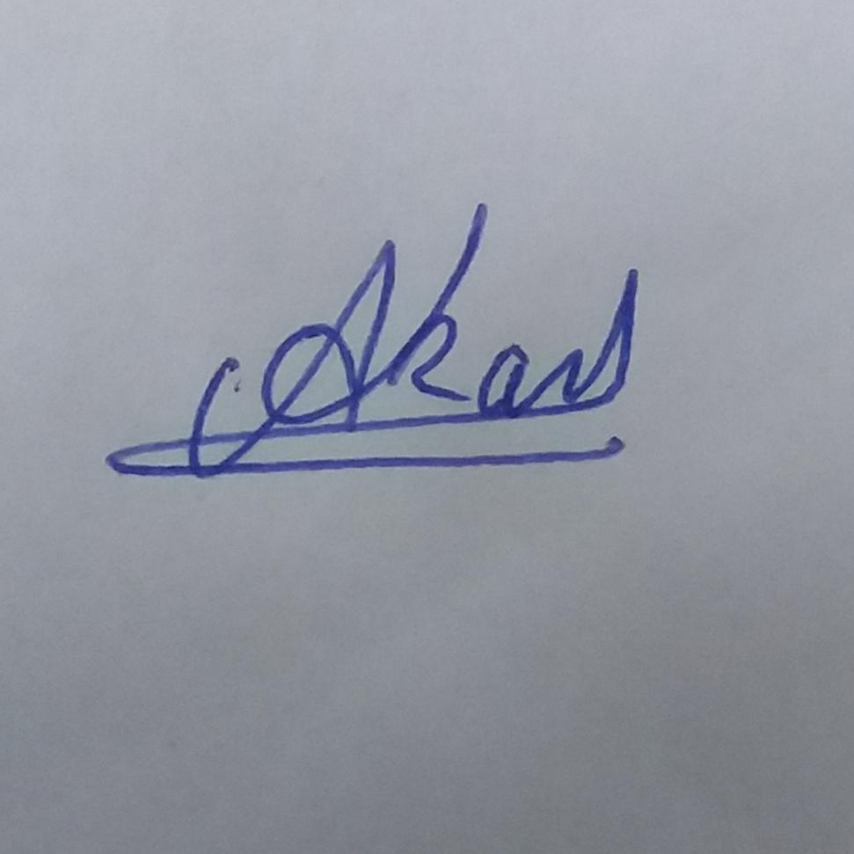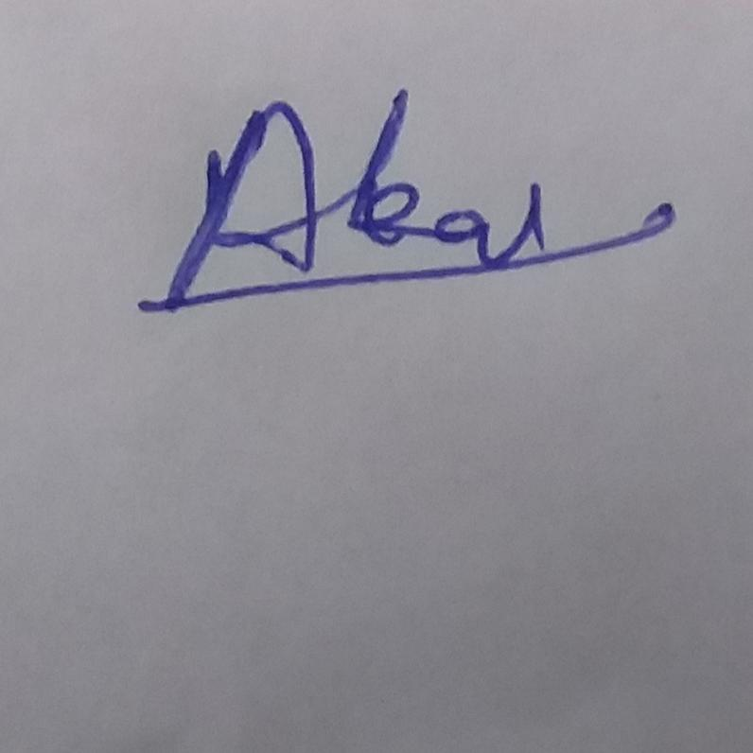

**RESULTS:**

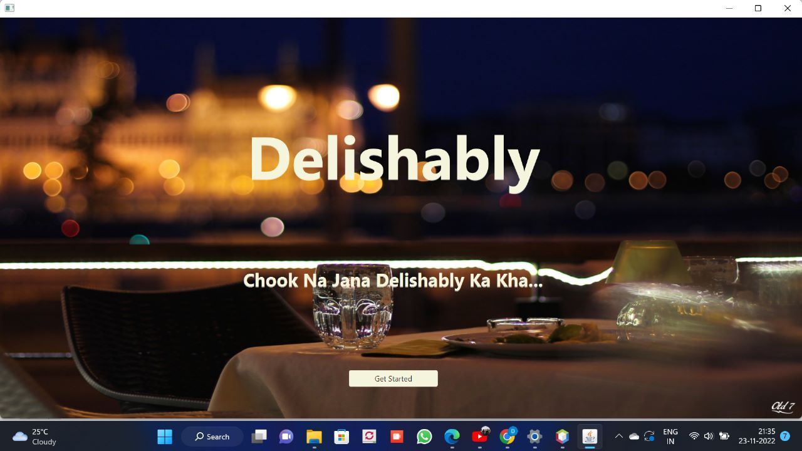 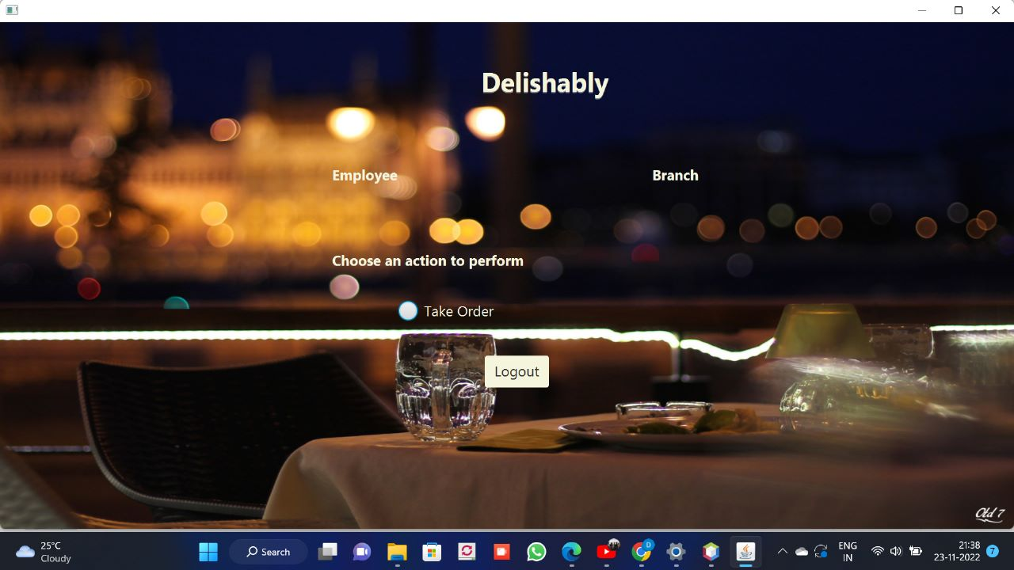

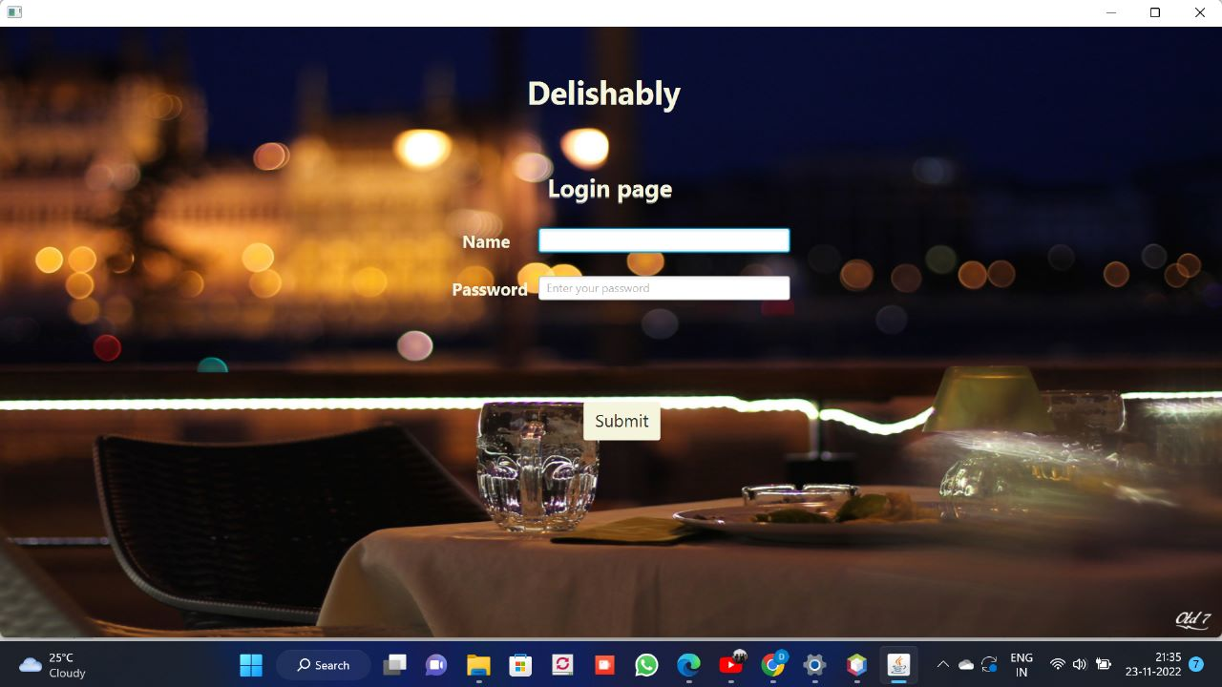 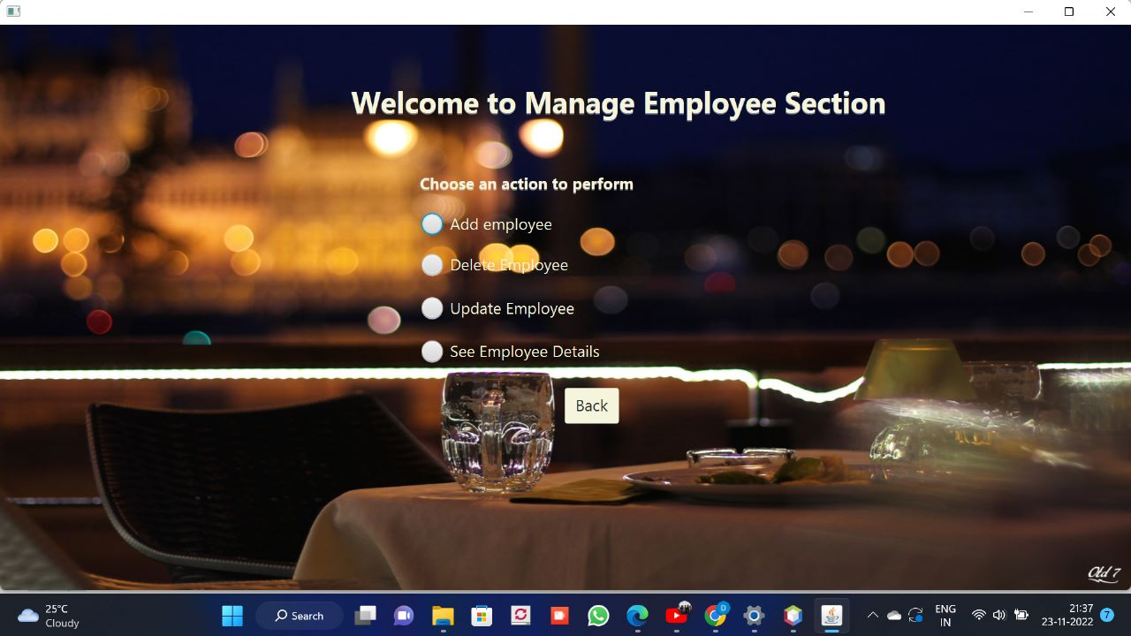

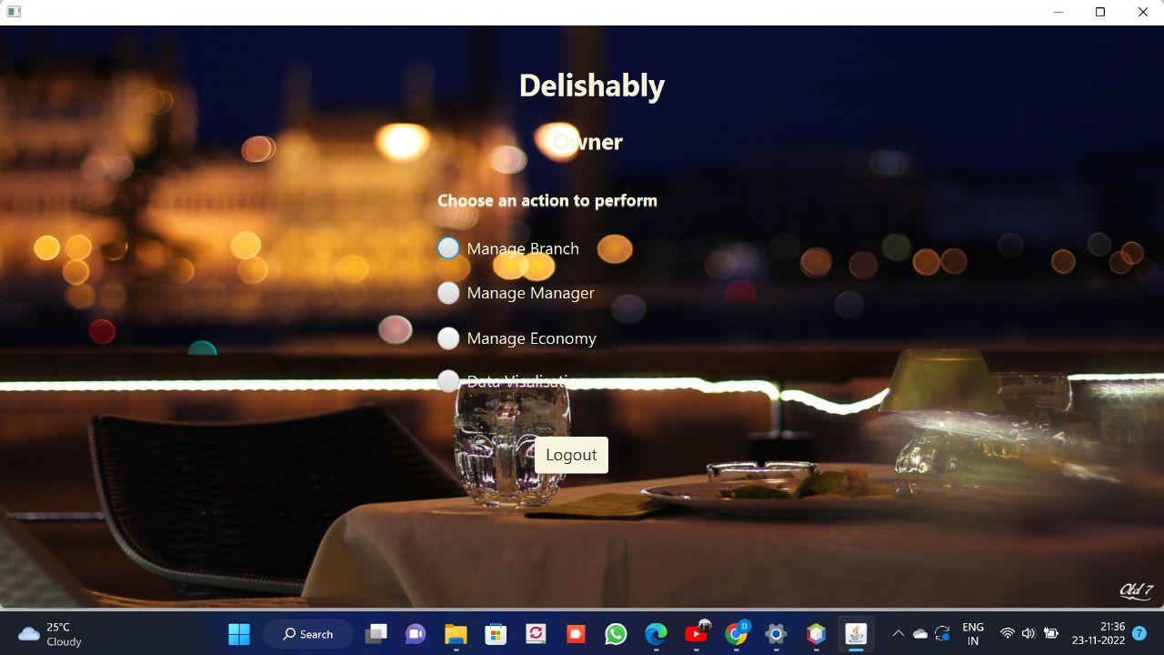 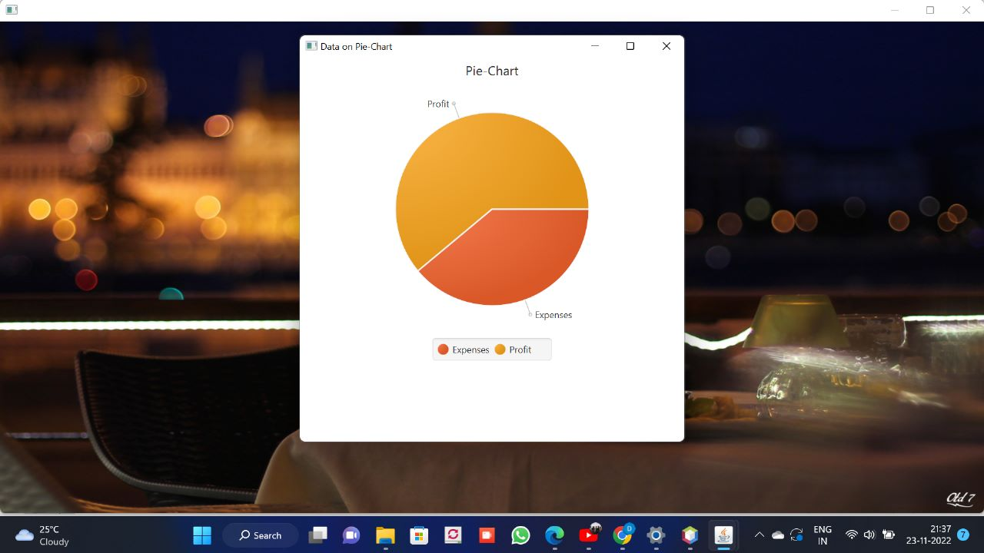

**CONCLUSION:**

**Project Overview:**

The system achieved all of its proposed priorities and functionalities.

The application increases the efficiency of the order-taking process and does help in keeping track of the Customers and the Economy of the Restaurant.

However, we deflected from the initial objective of only CLI-based to a GUI-based application.

**Further Development:**

The project was made under a time constraint, if given further time then the dataset that is printed in CLI could also have been integrated with the GUI. Further more functionalities could be added for more convenience of the end user. More Tables could have been added to collect more data and more ways of data visualization might have been possible.

**TECHNOLOGIES REQUIRED:**

**HARDWARE REQUIREMENTS:**

OPERATING SYSTEM : WINDOWS 7 and above

PROCESSOR : PENTIUM(ANY) or AMD ATHALON(3800) or above

RAM : 512 MB+

DVD/CD/HARDISK : if Back Up Required

**SOFTWARE REQUIREMENTS:**

* Java JDK
* MySQL
* MySQL Workbench
* Java JDBC API
* JavaFX Java Library
* Scene Builder